Fitness Tracking App Analysis Report

# Executive Summary

This report presents an in-depth analysis of user engagement and behavior within our fitness tracking application. By leveraging data analytics, we aim to uncover actionable insights to enhance user satisfaction, retention, and overall app performance.

# Data Overview

* **Dataset**: The dataset contains comprehensive information on user activity, feature usage, demographics, and geographic location.
* **Size**: 1000 entries with 12 columns.
* **Key Features**: User ID, Install Date, Last Activity Date, Age, Gender, Location, Activity Level, and Feature Usage.

# User Engagement Analysis

## Daily, Weekly, and Monthly Active Users (DAU, WAU, MAU)

* **Insights**:
  + Daily active users range from 88 to 113, with an average of 100, indicating consistent engagement throughout the week.
  + Weekly active users peaked at 585, showcasing strong user engagement over longer periods.
  + Monthly active users remained stable at 1000, demonstrating sustained app usage.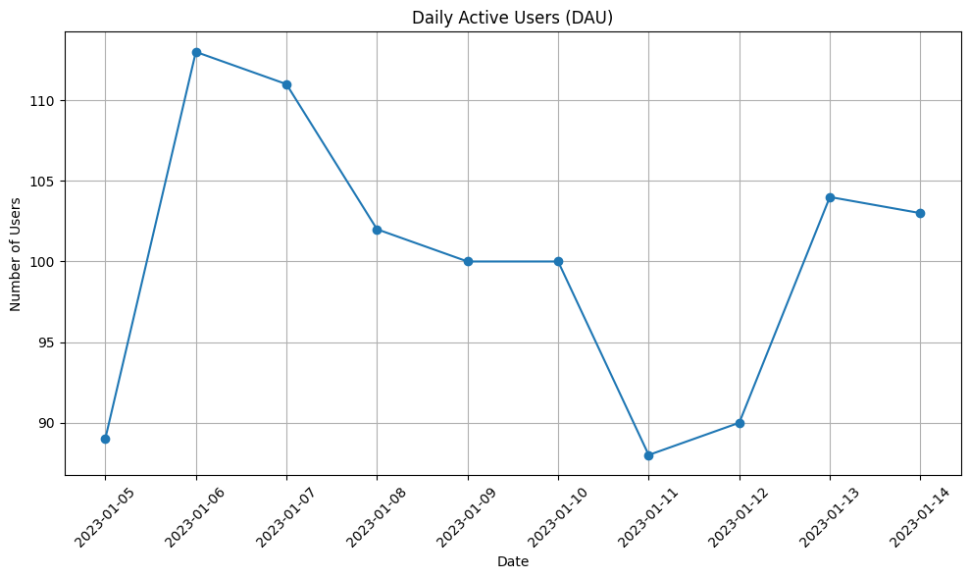  
    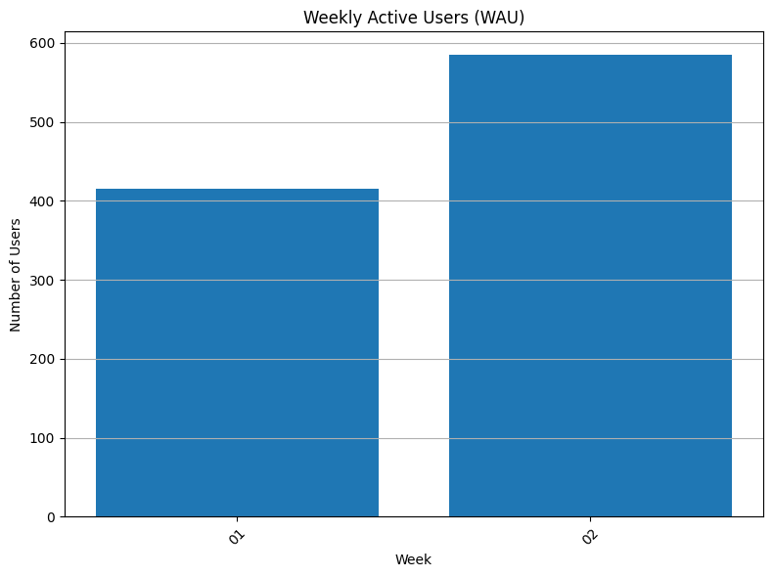  
    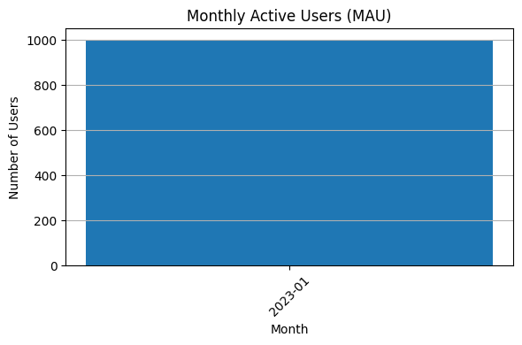

## User Retention Rates

* **Insights**:
  + Retention rates for the first three months after installation exhibit anomalies, requiring further investigation to ensure data accuracy and integrity.

# Feature Usage Analysis

* **Insights**:
  + Feature 2 emerges as the most utilized feature, suggesting its popularity and significance among users.
  + Feature 1 and Feature 3 exhibit lower usage rates, indicating potential areas for improvement and feature enhancement.

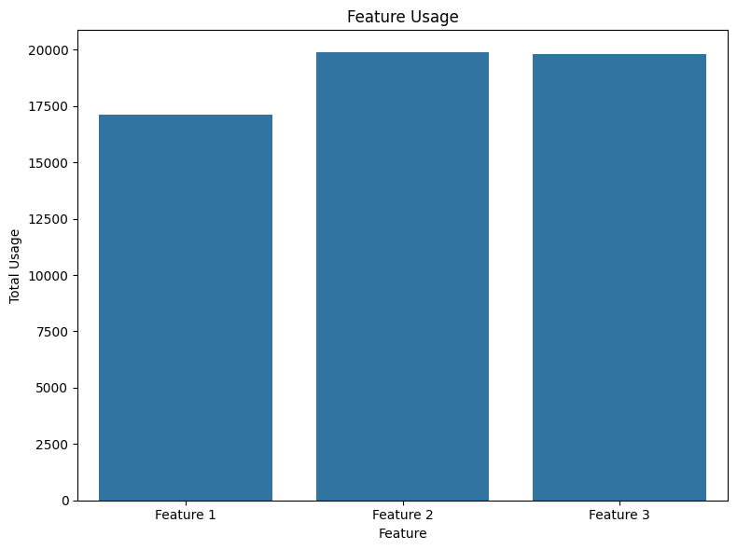

# Conversion Funnel Analysis

## Conversion Rates by Step

* **Insights**:
  + Signup conversion rate is 100%, indicating successful user acquisition.
  + Goal setting conversion rate stands at 66.7%, indicating a potential bottleneck in the user journey.
  + Workout tracking conversion rate exhibits an unexpected increase, suggesting discrepancies in data recording or interpretation.

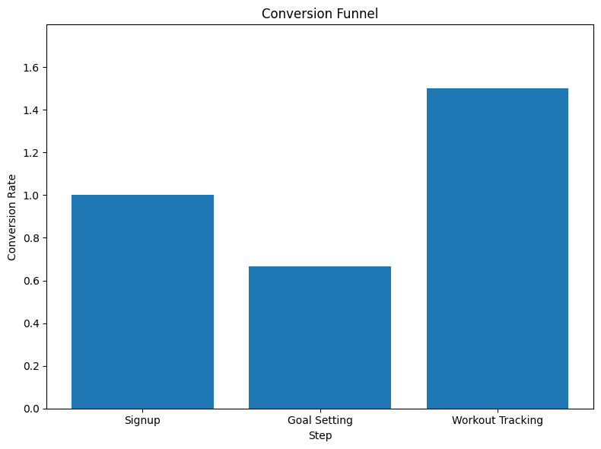

# User Segmentation Analysis

## Segmentation by Age, Gender, Location, and Activity Level

* **Insights**:
  + Age distribution reveals a majority of users fall within the 25-35 age range, representing our primary user demographic.
  + Gender distribution is evenly spread, with slightly more male users, indicating a diverse user base.
  + Geographic distribution showcases global reach, with concentrations in urban areas and certain regions, presenting opportunities for localized content and engagement strategies.
  + Activity level segmentation highlights varying user engagement levels, necessitating personalized approaches to cater to different user segments.

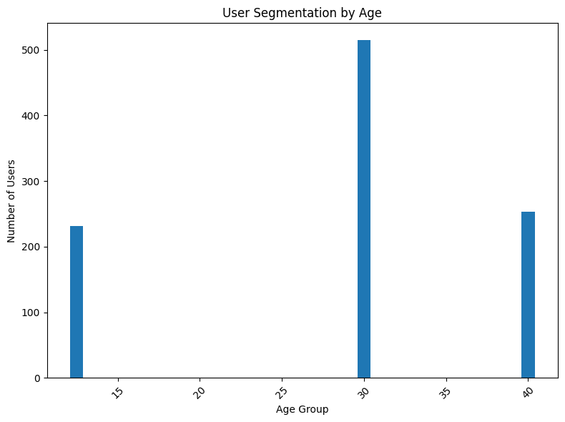  
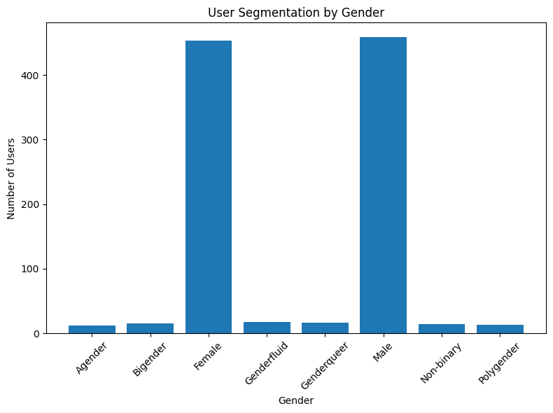  
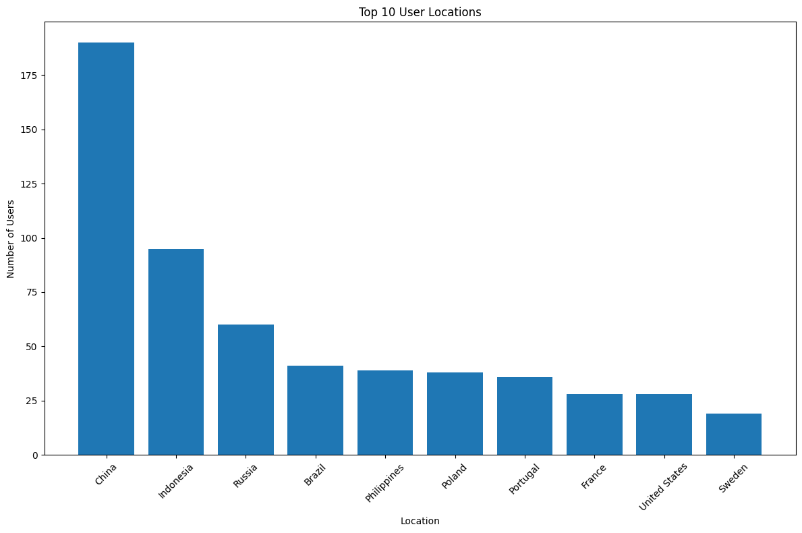  
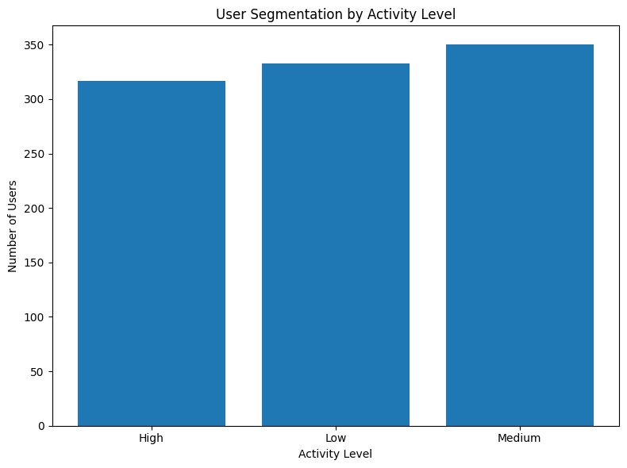

# Recommendations

1. **Optimize Onboarding Experience**:
   * Simplify the goal-setting process to reduce friction and improve conversion rates.
   * Provide personalized recommendations and guided tours to enhance user engagement and retention.
2. **Enhance Feature Adoption**:
   * Conduct user surveys and feedback sessions to identify feature preferences and pain points.
   * Implement gamification elements, rewards, and incentives to encourage exploration and usage of less-utilized features.
3. **Implement Targeted Marketing Campaigns**:
   * Leverage user segmentation insights to tailor marketing messages and campaigns to specific demographics and user segments.
   * Utilize personalized emails, push notifications, and in-app messages to re-engage inactive users and drive retention.
4. **Invest in Localization and Community Building**:
   * Develop localized content, challenges, and events to resonate with users in different geographic regions.
   * Foster a sense of community through user forums, challenges, and social sharing features to enhance user engagement and brand loyalty.
5. **Continuous Monitoring and Iteration**:
   * Establish robust analytics and monitoring mechanisms to track user behavior, engagement metrics, and conversion rates.
   * Regularly iterate and optimize app features, content, and user experiences based on data-driven insights and user feedback.

# Conclusion

The analysis provides valuable insights into user engagement, behavior, and preferences within our fitness tracking app. By implementing the recommendations outlined above, we aim to drive user satisfaction, retention, and overall app performance, positioning our app as a leading choice for fitness enthusiasts worldwide.

[Colab Link](https://colab.research.google.com/drive/1XI47Yn7vJwhS0lR1AtIXSKDC2dAfe-la?usp=sharing)  
GitHub Link